Utilitarian distribution of scarce surgical capacity during the COVID-19 crisis: a comparative modelling study

Benjamin Gravesteijn* ([0000-0001-8096-5803](https://orcid.org/0000-0001-8096-5803))1,2, Eline Krijkamp* (0000-0003-3970-2206)3,5, Jan van Busschbach ([0000-0002-8602-0381](https://orcid.org/0000-0002-8602-0381))4,5, Geert Geleijnse (0000-0002-4718-0032) 1, Sophie Bruinsma ([0000-0003-3634-9899](https://orcid.org/0000-0003-3634-9899))y, Celine van Lint ([0000-0002-7929-7622](https://orcid.org/0000-0002-7929-7622))y, Ernest van Veen ([0000-0002-5495-3996](https://orcid.org/0000-0002-5495-3996))2, Isabel Retel-Helmrich ([0000-0001-5257-395X](https://orcid.org/0000-0001-5257-395X))2, Jan van Saase ([0000-0003-2874-6667](https://orcid.org/0000-0003-2874-6667)), Hester Lingsma ([0000-0003-2063-9533](https://orcid.org/0000-0003-2063-9533))2, Rob Baatenburg de Jong ([0000-0001-7236-264X](https://orcid.org/0000-0001-7236-264X))1, and the Value Based OR team collaborators**

*Both authors contributed equally

Author affiliations - Request all authors to check the affiliation + ORCID ID

# 1) Department of Otorhinolaryngology (ENT); 2) Department of Public Health; 3) Department of Epidemiology; 4) Department of Medical Psychology, 5) Netherlands Institute for Health Sciences; x) Department XXX; y) Department - Erasmus University Medical Center, Rotterdam, the Netherlands.

** Expert panel: Alexandra Brandt-Kerkhof, Chris Bangma, Patrick Bindels, *Goudswaard*, *Polinder*, Mieke Hazes, Danielle van Diepen, Eva Maria Roes, Hanneke Takkenberg, Mark Vledder, Clemens Dirven, Ivo Beetz, Galema, Sjoerd Lagarde, Cees Verhoef. *Rode pen zonder naam? …*

Intention to be submitted to: NEJM (advice to try the COVID-19 special, because NEJM is not that into decision models - maybe for COVID they are) How about we also talk about “1. Emanuel EJ, Persad G, Upshur R, et al. Fair Allocation of Scarce Medical Resources in the Time of Covid-19. N Engl J Med 2020;1–7.” in the cover letter

“To ensure the fastest possible review process, we are asking authors not to submit presubmission inquiries related to Covid-19.” - NEJM site

--> We write with Lancet modelling studies as an example, perhaps second choice? (Lancet/Lancet Public Health/Lancet EClinical Medicine)

**Currently ~ 3600 words**

# Abstract

## Background

COVID-19 has put unprecedented pressure on health care systems worldwide. This has led to a reduction of the health care capacity available for regular care, especially for non-emergency surgical interventions. As a result, an accumulating group of patients is waiting for vital surgeries and societies are currently facing dilemmas about which patients should be prioritized. Therefore, our objective was to develop a decision model to estimate the effects of delay of surgical interventions on health that can be used for prioritization.

Methods

A simple cohort state-transition model was developed to simulate the long-term implications of delaying surgery. We compared scenarios of delaying surgery from two weeks up to a year (with intervals of 10 weeks) and no surgery at all. Model parameter values were based on Dutch and American registries, literature, and the global burden of disease study by the World Health Organization. For each surgical indication, we estimated the average expected quality-adjusted-life-years (QALYs) for the different scenarios. Urgency was defined as expected health loss due to delay of surgery, expressed in QALY loss per month (QALY/month). A probabilistic sensitivity analysis (PSA) was performed to incorporate parameter uncertainty in the model estimates. The model was applied to 34 semi-elective (not necessarily performed within 3 days, but ideally performed within 3 weeks) surgery on adults commonly performed in a Dutch academic hospital.

## Results

The maximum QALYs gained varied widely between procedures, from 0.54 QALYs (95% CI: 0.48 – 0.61) for resection of high-grade glioma to 10.3 QALYs 95% CI: 8.7 - 11.9) for kidney transplantation. The three most urgent interventions were surgically repairing an abdominal aneurysm of the aorta (-0.11 QALY/month, 95% CI: -0.13 – -0.09), implantation of a pacemaker (-0.11 QALY/month, 95% CI: -0.22 - -0.04), and the resection of cholangiocarcinoma (-0.09 QALY/month, 95% CI: -0.12 - -0.06). The three least urgent interventions were the placing of a shunt for dialysis (-0.01 QALY/month, 95% CI: -0.01 – -0.005), resection of thyroid cancer (-0.01 QALY/month, 95% CI: -0.02 - -0.01), and the resection of mild salivary gland carcinoma (-0.01 QALY/month, 95% CI: -0.03 - -0.01).

## Conclusion

with our decision model and can guide prioritization of surgical care from a utilitarian perspective (i.e. minimizing health loss for the total population) in times of scarcity (due to COVID-19). Placing this tool in the context of different ethical perspectives and combining it with capacity management tools is key to achieve large-scale implementation.

## Background

COVID-19 has put unprecedented pressure on health care systems worldwide. The health care demand of the pandemic supersedes total usual health care capacity, far beyond the demand that was imposed by the 2017 influenza pandemic.1,2 This pressure on the available health care capacity impacts the continuity of usual care.

We can identify multiple causes of the disruption of usual care. At first, because wards and operating theaters are converted to COVID-19 care facilities, fewer non-COVID-19 patients can be admitted or undergo surgery.3 Second, because physicians are deployed to care for COVID-19 patients, fewer patients are be seen and referred.4,5In the Netherlands, we observed a 90% decrease in referrals during the first part of the crisis compared to previous years.6 Finally, fear of the virus may leave sick people reluctant to seek the care they need 4,5, as has been seen in similar health crises like the SARS epidemic.7

Delay in surgical care may impose complex health care problems. In the first part of the crisis in the Netherlands, 75-90% fewer surgeries were performed compared to previous years.6 The impact on health care logistics of these delays can be substantial: A modelling study for orthopedic surgery showed that if elective orthopedic surgery would have resumed in June 2020 in the USA, it would have taken 7-16 months until the health-care system performed at 90% of the expected pre-pandemic forecasted volume of surgery.8 Because an accumulating group of patients is waiting for vital surgeries, our society is facing dilemmas about which patients should be prioritized.

Experts in the field of medical ethics, recently proposed that the distribution of scarce (surgical) resources can be evaluated by the following four ethical values: 1) The scarce resources are used to maximize the benefits; 2) People are treated equally; 3) Instrumental value is promoted and rewarded; 4) The worst off are prioritized.2 In the context of a pandemic, it justifiable to focus on maximizing the benefits (first value). 9–13 This is consistent with utilitarian ethical perspectives, which emphasize population outcomes over individual outcomes.14

As stated by Emanuel et al., “The question is not whether to set priorities, but how to do so ethically and consistently, rather than basing decisions on individual institutions’ approaches or a clinician’s intuition in the heat of the moment”.2 In reality, however, surgical patients are most often triaged by experts from the respective surgical fields.15 Experts, for which it is known that the agreement of prioritization is low16. Additionally, prioritization across different disciplines is complicated by the high degree of specialization in modern medicine. To our knowledge, no objective, quantitative, evidence-based approach has yet been developed.

Therefore, the aim of our study is to develop a decision model to estimate the impact of postponing surgical intervention on health. This measure of urgency might be used to guide prioritization of surgical intervention form a utilitarian perspective. Although this strategy was conceived during the COVID-19 pandemic, our secondary aim is to ensure applicability to the context of upcoming pandemics, as well as to the context of usual care.

## Methods

This manuscript has been written conform the CHEER guidelines for reporting health-economical evaluations17. The model was built in R software (R Core Team (2013). R: A language and environment for statistical computing. R Foundation for Statistical Computing, Vienna, Austria.) and the code is based on tutorials provided by the DARTH workgroup.18,19 The model code and input data are freely available via a GitHub repository: [https://github.com/erasmusmc-mgz/VB_OR_t](https://github.com/erasmusmc-mgz/VB_OR_triage)riage.

### Patients and setting

The procedures evaluated in this study comprised of non-pediatric, semi-elective surgeries. A semi-elective procedure was defined as a procedure that is non-urgent, but ideally performed within three weeks. A selection of semi-elective procedures for this modelling study was based on electronic patient registry data of the Erasmus MC (University Medical Center based in Rotterdam, The Netherlands). From this patient registry, we retrieved the surgery time, length of stay at an intensive care unit (ICU), and length of stay at a non-ICU unit of all non-urgent procedures between July 2017 and May 2020. Procedures that were performed at least 80 times were selected. These selected procedures were consecutively classified by two senior clinicians (JvS – emeritus professor internal medecine, RBdJ – head of the department of head and neck surgery) as a semi-elective procedure based on their experience. Ultimately, 61 semi-elective procedures were selected. Where relevant, we distinguished mild and severe cases undergoing the procedure.

The simulated patient populations in this study are average patients with an indication of one of the selected 61 non-pediatric semi-elective procedures. The average age of the patients was used as the initial age of the simulated cohort in the model. Where possible, survival data from Dutch registries was used. In this study, we only focus on health benefits. Because benefits have more “value” in the near than in the distant future, it is common to perform discounting: this is a procedure where benefits later in the time scheme are weighed less. A discount rate of 0.015 per year for health benefits was used, as this is common practice in the Netherlands20:

### Markov model

To quantify the long-term health effects of surgery delay we made use of a Markov cohort state-transition model (cSTM). This model type is frequently used in clinical decision analysis, because it is relatively simple to build, easy to communicate and can synthesize data from different sources to estimate long-term outcomes.21,22 A cSTM simulates a hypothetical cohort of patients over a defined period in discrete time cycles to estimate the average time individuals spend in the various health states.21,23 Based on the time spent in these states, health benefits can be calculated. Possible health benefits that can be calculated include the expected life years or quality adjusted life years (QALYs) - the surrogate measure of life years with utility (“quality of life”).23,24

For our aim, we developed a three-state cSTM with a preoperative state, a postoperative state, and a dead state (Figure 1). The entire cohort starts in the preoperative state, and was followed their entire remaining lifespan, until they are 100 years, using weekly cycles. The transition from the preoperative state to the postoperative state was set to a specific week, depending on the scenario. We evaluated scenarios where patients were treated immediately (delay of two weeks) up to a delay of a year using intervals of ten weeks. In addition, we evaluated the scenario where nobody ever received treatment: this was modeled by following patients their remaining lifespan in the preoperative health state. In all scenarios, the transitions from the pre- and postoperative states to the absorbing state dead were based on survival data, as described in the next section.

### Survival

Two types of survival data were required to model the survival in the pre- and postoperative health state, the survival with and without treatment respectively. The survival data with treatment was obtained from Dutch registries for oncological25 and cardiothoracic26 surgical procedures, and from literature for the other procedures. The survival data without treatment for all procedures is based on data from published studies. If either survival with or without treatment was lacking, the reported treatment effect (preferably evaluated in a randomized controlled trial) was used to calculate the missing survival parameter. An overview of all parameter values and their sources can be found in Appendix A.

The disease specific mortality was added to the overall age-specific background mortality from the Dutch Central Bureau of Statistics.27 All survival data, including the disease specific mortality and age-specific background mortality, had to be converted to mortality risk per week (formulas presented in Appendix C).

Since postponing surgery can have consequences on the effectiveness of the procedure, we included an additional parameter to the model reflecting the time until no effect can be expected of treatment on survival. In practice, this means that when this time has passed, we assumed that the surgery did not have any effect on the survival of the patient anymore. This time is often important in oncological surgeries, where after a specific time a tumor becomes inoperable. This was translated in the model by setting the postoperative survival equal to the preoperative survival if the delay was longer than this time. The data for this time to no effect of survival came from literature (Appendix A). For most procedures, only data about the minimal delay not associated with worse survival was evaluated in the literature. For those procedures, we assumed the upper limit of this parameter to be a year (the maximum delay we evaluated), and the mean of the lower and upper limit as average.

### Quality of life

The quality of life (QoL) values in the preoperative and postoperative health states were based on disutility weights from the Global Burden of Disease Study 2016.28 This study reports disability weights for nonfatal health outcomes. Disability weights represent the magnitude of health loss associated with specific health outcomes, where 0 represents a state of full health and 1 represents death. These weights can be used to calculate years lived with disability (YLD).29 The YLD summed with the years of life lost (YLLs) give the disability adjusted life years (DALY).30 A surrogate measure where one DALY represents losing one year in full health. This is the opposite of the QALY, which represents a year spent in full health. For our study, we used the composite of the disability weight as QoL values to calculate QALYs.

Where possible, the disability weight of health states was directly based on the GBD 2016 update IHME_GBD_2016_DISABILITY_WEIGHTS_Y2017M09D14 (downloaded from <http://ghdx.healthdata.org/gbd-2016>). For the remaining health states, we followed the method of a calibrated visual analogue scale (VAS) as described by Stouthard et al.31 We made use of a calibrated VAS with WHO data and the missing data on pre- and postoperative QoL was mapped on the WHO data by an expert panel. The expert panel consisted of a diverse group of Dutch health care professionals, both surgeons (e.g. cardiothoracic surgeons and gynecologic surgeons) as well as generalists (e.g. internists, geriatrists and GPs). Appendix D provided the calibrated VAS used in the exercise as well as summary of the participating health care professionals. The mean and 95% confidence interval of the mapped QoL scores was used in the model.

We estimated eight health states (three procedures) twice in two separate sessions. The results were compared using two-sided t-tests. The estimates of the first session were used.

Do we need details, like done 2 evening? And data handling of the results?

@Jan v B? Could you please check/help improving this paragraph and what need to be included in the appendix?

Similar to the parameter for survival, we also included a parameter for the time until no effect of treatment can be expected on QoL. When the delay in surgery is higher than the time indicated by this parameter, the utility of the postoperative state will be equal to the utility of the preoperative state.

### Analysis

Parameter uncertainty was incorporated using a probabilistic sensitivity analysis. Instead of simulating all scenarios with one estimate per parameter, we simulated all scenarios with 100 parameter sets. These parameters sets were drawn from the distribution of each parameter described by the 95% confidence interval. We assumed triangle distributions for the survival probabilities, the time to no effect on survival or QoL, and utilities; we assumed lognormal distributions for relative treatment effects; and we assumed normal distributions for age. This procedure results in 100 model estimates per scenario. The 50th, 2.5th, and 97.5th percentile of these estimates were calculated, which correspond to the main estimate and the lower and upper limit of the 95% confidence interval, respectively.

To calculate QALY loss due to delay, we subtracted the QALYs associated with delaying surgery for 52 weeks from the QALYs associated with delaying the surgery for 2 weeks. This gives the QALY loss per 50 weeks, which we converted it to QALY loss per month.

Finally, the model results were visually compared to the capacity requirements, obtained from the electronic patient registry.

### Assumptions

Above, we have described the design of the model. This design translates to the following core assumptions:

* The health benefit of the surgical procedure for the average patient is evaluated.
* The model does not include complications or a period of recovery, both of which can reduce QoL temporarily.
* Surgical procedures are successful: no increased risk of mortality during surgery is assumed.
* The COVID-19 context does not impact the performance of the surgical procedures.

The output of the model should therefore be interpreted as the maximum health gain associated by performing the procedure successfully for an average patient, in an OR-setting not complicated by COVID-19. As for the QALY loss per month, we assume that complications and harm at various delays are equal and cancel each other out. Therefore, this measure of urgency can be compared across treatments with varying associated harm.

## Results

Full input data was found for 34/61 (56%) selected procedures. These 34 evaluated procedures comprised of 47% of the total semi-elective program in our hospital. We evaluated 8 (24%) cardiothoracic procedures, 19 (56%) oncological procedures, 2 (6%) transplantations, 4 (11%) vascular procedures, and 1 (3%) other type of procedure.

For 21/34 (62%) procedures, the treatment effect was used to calculate the survival without treatment from the survival with treatment. For 20 (59%) procedures, the utility of the pre- and postoperative health state was estimated by the expert panel. Out of the eight health states (of three procedures) that were estimated twice by the panel, six health states did not differ significantly between the two sessions (table 3 Appendix B). The only procedure where a “time-to-no-effect-on-QoL” was assumed was the endarterectomy for symptomatic carotid artery stenosis (59 weeks, range: 32 – 94 weeks). For 16 (47%) procedures, we assumed a “time-to-no-effect-of-treatment-on-survival”. All these procedures were oncological procedures. Input parameters varied widely between procedures (Figure 2).

The input parameters, their source25,26,32–80, and the corresponding model output for every procedure are presented in Appendix A.

The maximum benefit expected from the evaluated procedures ranged from 0.54 QALYs (95% CI: 0.48 - 0.61) for resection of high-grade glioma to 10.3 QALYs (95% CI: 8.7 - 11.9) for kidney transplantation (Figure 3). The ranking based on QALYs gained by surgery was moderately correlated with the ranking based on LYs gained by surgery:the Spearman rank correlation coefficient between the ranking of procedures based on LYs and QALYs was 0.35 (p=0.045).

The urgency of the procedures ranged from -0.01 QALY/month (95% CI: -0.01 - -0.00) for placing a shunt for dialysis, to -0.11 QALY/month (-0.13 - -0.09) for the surgical repair of an abdominal aneurysm of the aorta (Figure 4, and table 1 Appendix B). Procedures that were associated with a high expected QALY benefit by surgery, did not always lose more QALYs per month as well: The Spearman correlation coefficient between the ranking of health benefit in terms of QALYs and QALY loss per month was 0.31 (p=0.07). The most urgent procedures after surgical repair of an abdominal aneurysm of the aorta were pacemaker implantation (-0.11 QALY/month, 95% CI: -0.22 - -0.04), and resection of cholangiocarcinoma (-0.09 QALY/month, 95% CI: -0.12 - -0.06). After placing a shunt for end-stage renal disease patients, the least urgent procedures were resection of thyroid cancer (-0.01 QALY/month, 95% CI: -0.02 - -0.01) and the resection of mild salivary gland carcinoma (-0.01 QALY/month, 95% CI: -0.03 - -0.01) (Appendix B). When ordering procedures based on LYs lost per month instead of QALYs lost per month, resection of non-small cell lung carcinoma was ranked substantially lower (from rank 5 to rank 19), while the implantation of a left-ventricle assist device was ranked substantially higher (from rank 8 to rank 1).

Procedures that are ranked high in terms of urgency and had relative short surgery time and length of stay include repair of atrial septum defects (surgery time: 74 min [IQR: 56-131]; length of non-ICU stay: 1.3 days [IQR: 0.6-1.95]), pacemaker implantations (surgery time: 115 min [82-154]; length of non-ICU stay: 1.4 days [1.1-2.1]), and surgical repair of an abdominal aneurysm of the aorta (surgery time: 246 min [166 - 305]; length of non-ICU stay: 3.8 days [2.2 - 7.1]) (Figure 5). Kidney transplant is an urgent procedure but requires substantial amounts of capacity (surgery time: 291 min [244 - 341]; length of non-ICU stay: 11 days [7.5 - 12.3]). Liver transplant is similarly urgent but requires a lot of capacity (surgery time: 875 min [797 - 957]; length of non-ICU stay: 9.5 days [2 - 18.7]) (table 2 Appendix B).

## Discussion

Our decision model can be used to guide prioritization of surgical interventions from a utilitarian perspective, by estimating urgency based the expected health loss of delay. Our results demonstrate that we can rank semi-elective surgeries based on their urgency using a simple three-states cSTM. Using this approach, we found that repairing an abdominal aneurysm of the aorta, implantation of a pacemaker, and the resection of cholangiocarcinoma were the most urgent procedures. Less urgent procedures were placing of a shunt for dialysis, resection of thyroid cancer, and the resection of mild salivary gland carcinoma. We also identified liver transplantation as being a relatively urgent procedure with an exceptionally long surgery time and length of stay.

We propose a prioritization based on QALY loss per month. To illustrate what this measure actually represents, we take the most urgent procedure as an example. Surgically repairing an abdominal aneurysm of the aorta is associated with a QALY loss of 0.11 per month – in part due to the prospect of a potentially life-threatening rupture preoperatively, in part due to the increase in survival after surgery. This implies that if this procedure would be postponed by a month, patients with this surgical indication lose approximately 40 days (0.11*365) spent in perfect health of their remaining expected QALYs gained by surgery. Although the personal value of a loss of 40 days spent in perfect health can be different for everybody, it is a substantial loss compared to the least urgent surgery: a similar calculation for the placing of a shunt for dialysis is associated with 4 days less spent in perfect health by delaying the procedure by a month.

Although this approach rationalizes and objectively quantifies urgency from a utilitarian perspective, it needs to be complemented by other perspective to be used effectively in practice. One proposal for implementation would be to provide the surgical triage team15 with a list of most urgent procedure in their hospital. When deciding what patients to schedule for next week, these procedures should be scheduled first. If there is still remaining capacity, the team can triage patients based on other criteria, e.g. longer waiting times or high risk on mortality. This more flexible approach would be consistent with rule utilitarianism, which emphasizes that rules should be adhered to which *in general* produce the most benefit2,14, while it also gives room to alternative ethical perspectives such as the rule of rescue.81 More implementation strategies should be explored and ethically evaluated.

~~Hier moeten we ook nog iets zeggen over het feit dat we naar “gemiddelde” patienten kijken. Dat heeft het voordeel dat er altijd nog een geïndividualiseerd besluit door arts en dokter genomen kan worden. In dat besluit kunnen overwegingen betreffende comorbiditeit, stadium en histologisch subtype worden meegenomen.~~

There are practical advantages of comparing “average patients” on urgency, despite the fact that there is no such thing as an “average patient”: It prevents our approach from systematically discriminating against a specific group of patients. Our approach would only discriminate if specific socioeconomic groups would suffer more frequently from diseases that are less urgent (e.g. high-grade glioma, metastasized colon carcinoma). It is known that lower socioeconomic groups are more prone to develop cancers that have clear association with unhealthy behavior, such as lung cancer.82 However, these diseases do not systematically rank low in our approach. Moreoever, by comparing the average patients across specialties on urgency, we give way to shared decision making: we feel that next to a quantitative estimation of urgency from a utilitarian perspective, individual patient’s preferences, social contexts, and comorbidity should also be included in decision making process of prioritization.

Since all models are, by definition, a simplification of reality, our model has several limitations. First, we assume that all surgeries are successful. We do not simulate adverse events, like major bleedings or death due to surgery. We also do not incorporate the potential reduction of QoL due to these adverse events or QoL reduction of a temporary period of recovery after surgery. Because of these assumptions, the overall QALYs associated with the surgery should not be interpreted as absolute estimate but can be considered the maximum possible QALYs that can be acquired. However, these assumptions were considered reasonable to achieve the main goal of this study: when surgery without delay is compared to surgery with delay, the harm in both scenarios is similar and therefore cancels out.

Second, we do not take the risk of the coronavirus transmission (patient – doctor, doctor – patient) and the possible consequences for the patient population into account. Several groups are currently studying the effects of upscaling surgery on the COVID-19 transmission (cite). It is conceivable that these results might be relevant to take into account when prioritizing surgical procedures.

Third, we used a linear approximation to quantify urgency by delaying surgery up to a year. Some procedures did show a slightly steeper decrease in the first phase of delay. We have chosen for this pragmatic approach because we did not specifically design the model to validly estimate the curvature in this descend.

Fourth, there are methodological issues with the fact that we calculated QALYs by the disutility weights by the WHO. … There are also multiple methodological, ethical, and contextual disadvantages of using QALYs.83

Our model was tailored to the Dutch context by using the Dutch discount rate, and Dutch registry data. However, a substantial amount of the evidence used in the model originated from various non-Dutch sources. Moreover, with simple modifications, and using international data, the model can easily be applied to different contexts. We believe that the ranking of urgency would not be affected substantially by including other survival data.

We are aware that the mentioned limitations seriously impact the validity of our estimates. However, our approach is more transparent, more evidence-based, and more objective than the alternative strategy of triaging based on expert opinion. Moreover, the model can be developed further by also modeling complications, recovery periods and the effect of comorbidity on survival. Therefore, this study can be considered the first step towards a triaging strategy which optimizes surgical benefit in times of scarcity in surgical capacity, such as during the COVID-19 pandemic. The next steps include considering a wider range of procedures, exploring and evaluating implementation strategies, and applying the model to a variety of settings.

Conclusion

Our decision model guides prioritization of surgical care in times of scarcity (due to COVID-19) in surgical capacity from a utilitarian perspective. The expected health loss due to delay could be *reliably* quantified for semi-elective surgical procedures in our hospital. This observation can help to minimize health losses when trying to overcome delay in surgical procedures. Placing this tool in the context of different ethical perspectives and combining it with capacity management tools is key to achieve large-scale implementation.

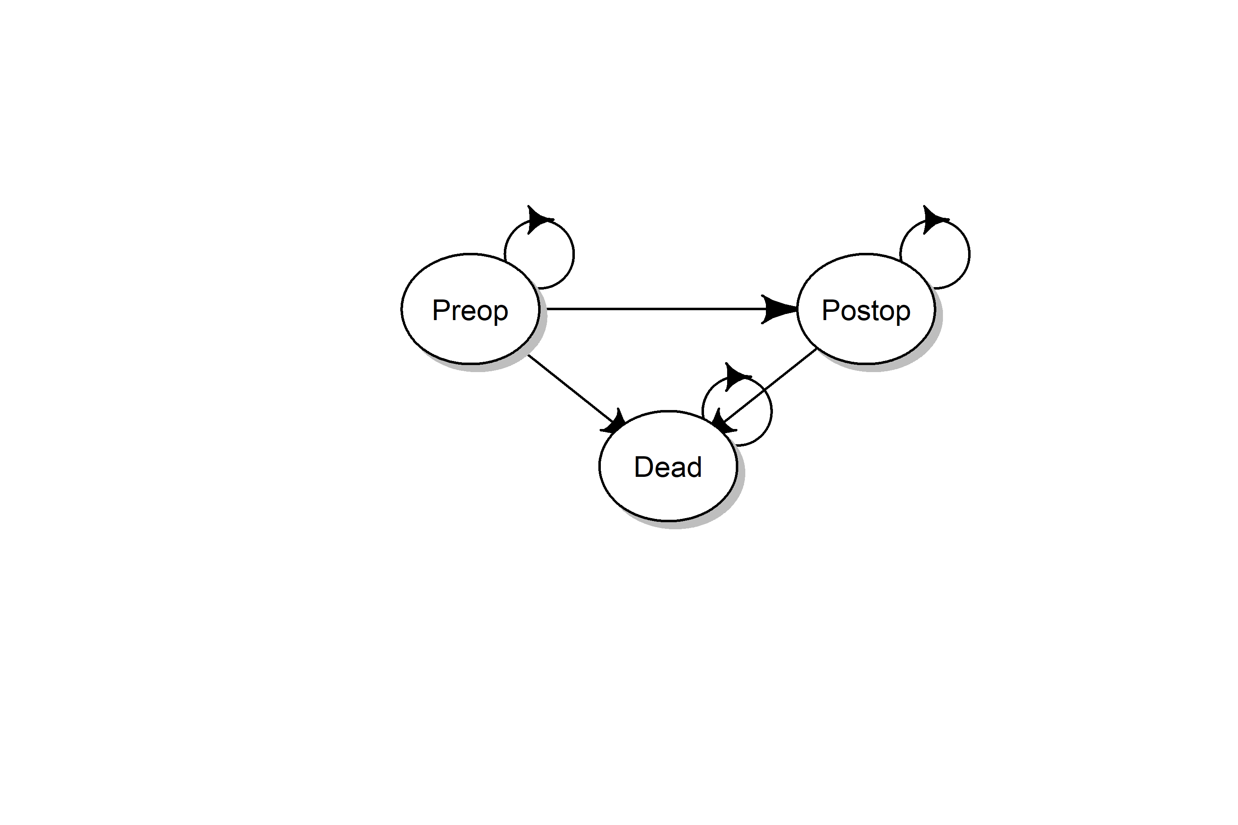

Figure 1, state-transition diagram of the model. The model is a Markov model consisting of three states: a preoperative state (Preop), a postoperative state (Postop), and the absorbing state Dead. All patient eligible of semi-elective surgery start in the Preop health states. From the Preop states they can die, transition to dead, or continue to wait for their surgery. At the time of surgery, which is determined by the scenario analysis, all individuals still alive in the Preop health state transition to the Postop health state. The remaining lifetime the cohort is followed. They can die, transition for the Postop state to dead or stay alive in the Postop health state.

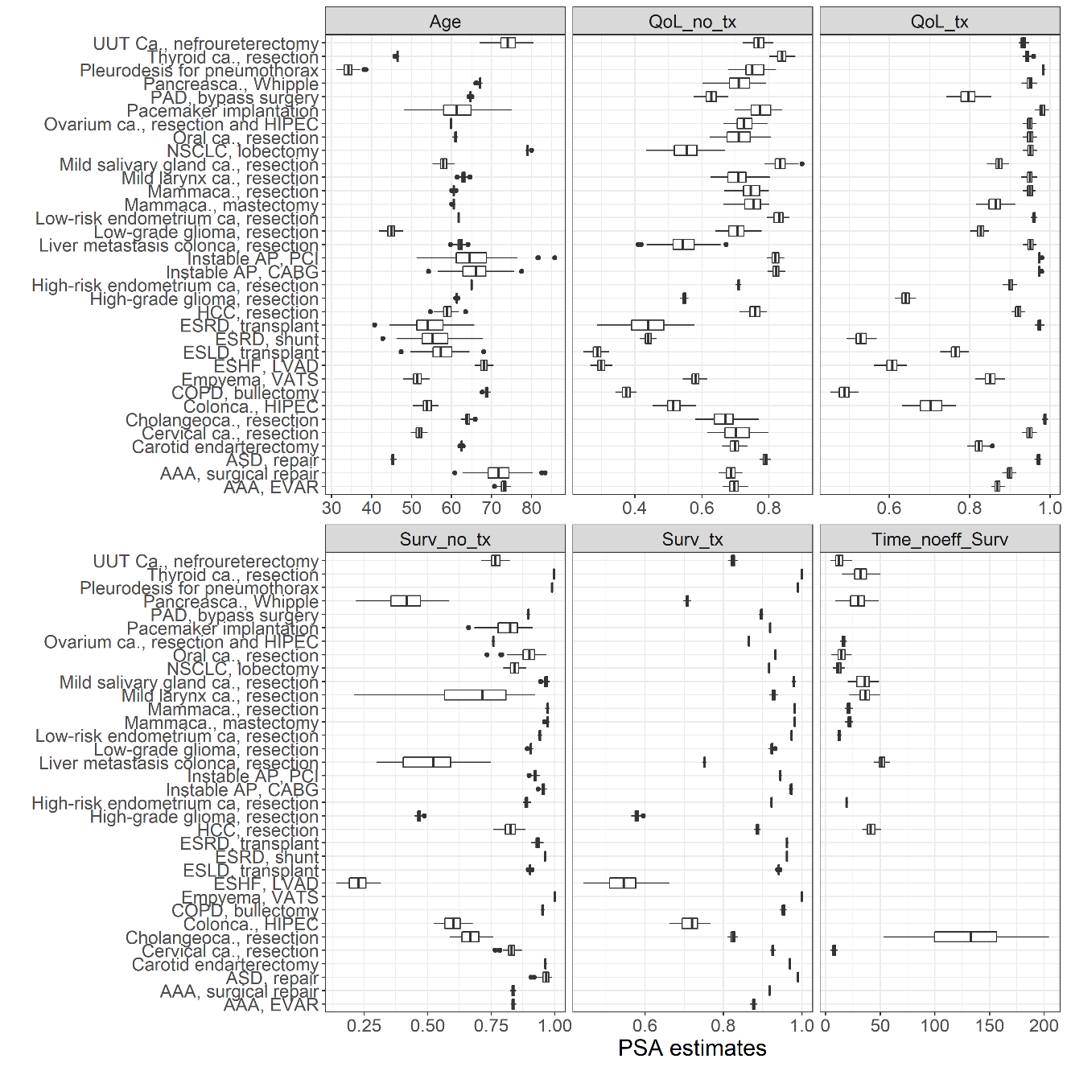

Figure 2, input parameters for the model. For a full list of input parameters per disease and source, see appendix A. Qol_no_tx: Quality of Life without treatment; QoL_tx: quality of life with treatment; Surv_no_tx: 1-year survival probability without treatment; Surv_tx: 1-year survival probability with treatment; Time_noeff_surv: days until no treatment is effective. ESRD: end-stage renal disease; ASD: atrial septum defect; VATS: video assisted thoracoscopic surgery; ESLD: end-stage liver disease; AAA: aneurysm of the abdominal aorta; AP: angina pectoris; CABG: coronary artery bypass graft; PCI: percutaneous coronary intervention; NSCLC: non-small cell lung carcinoma; EVAR: endovascular aortic repair; ca.: carcinoma; PAD: peripheral arterial disease; HCC: hepatocellular carcinoma; ESHF: end-stage heart failure; HIPEC: hyperthermic intraperitoneal chemotherapy.

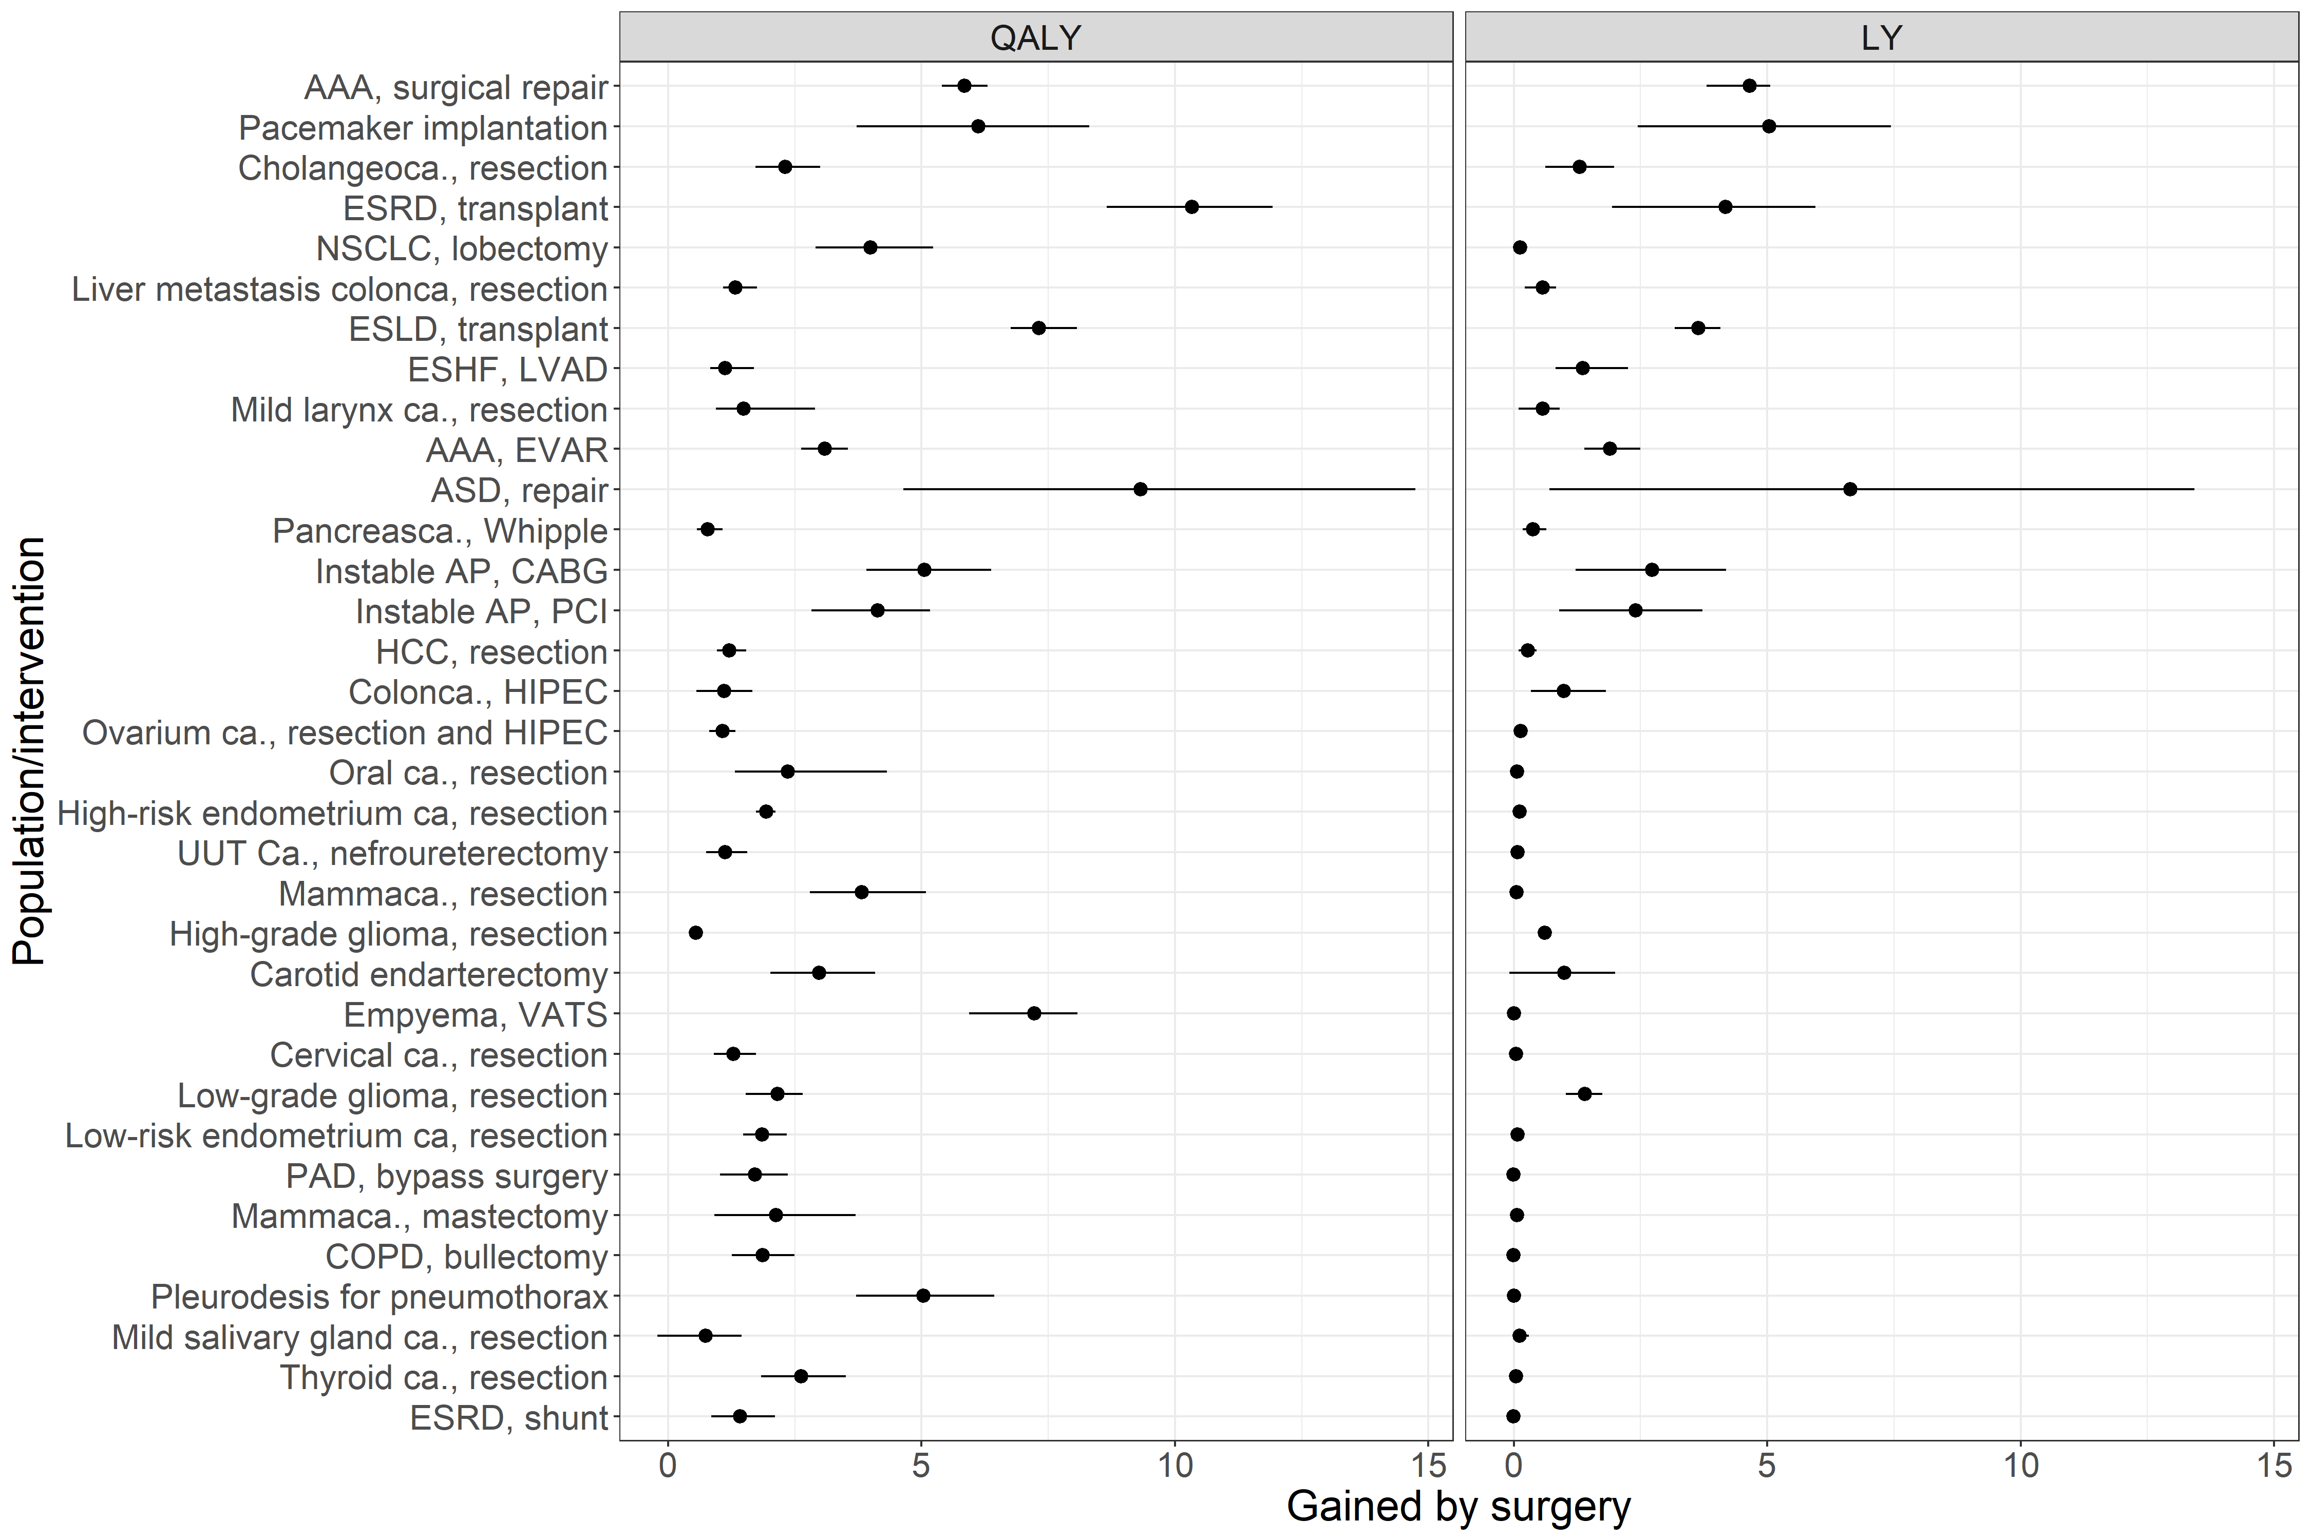

Figure 3, the maximum expected QALYs and LYs per intervention, in descending order of urgency (see figure 4). The estimates and 95% confidence intervals are shown. The model output for no surgery was subtracted from the model output for a delay of 2 weeks. The actual data are presented in appendix B. ESRD: end-stage renal disease; ASD: atrial septum defect; VATS: video assisted thoracoscopic surgery; ESLD: end-stage liver disease; AAA: aneurysm of the abdominal aorta; AP: angina pectoris; CABG: coronary artery bypass graft; PCI: percutaneous coronary intervention; NSCLC: non-small cell lung carcinoma; EVAR: endovascular aortic repair; ca.: carcinoma; PAD: peripheral arterial disease; HCC: hepatocellular carcinoma; ESHF: end-stage heart failure; HIPEC: hyperthermic intraperitoneal chemotherapy.

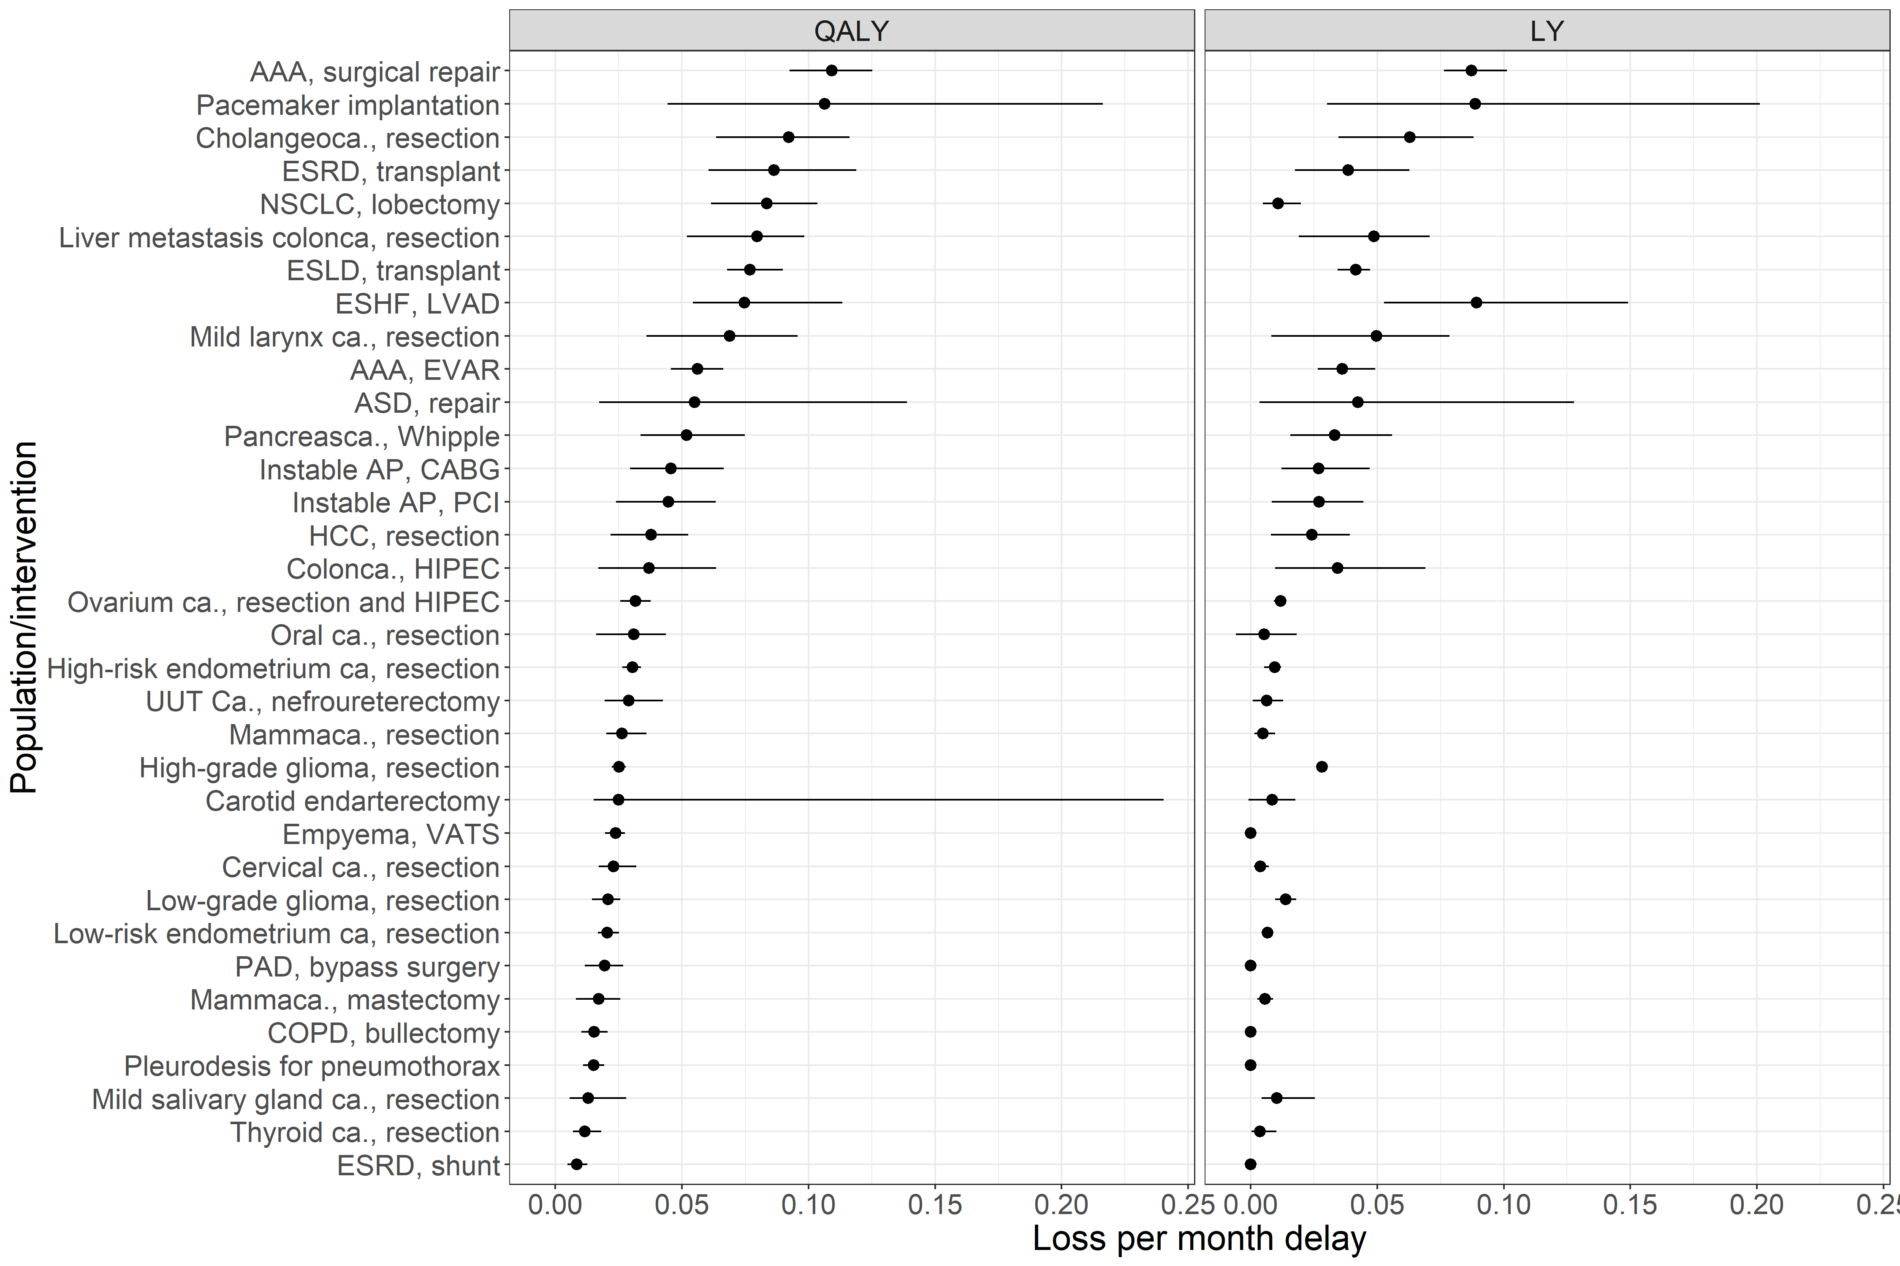

Figure 4, the average loss of QALYs and LYs per month of delay for the investigated interventions based on the simulation of surgery delay of 52 weeks. The estimates and 95% confidence intervals are shown. The actual data are presented in appendix B. ESRD: end-stage renal disease; ASD: atrial septum defect; VATS: video assisted thoracoscopic surgery; ESLD: end-stage liver disease; AAA: aneurysm of the abdominal aorta; AP: angina pectoris; CABG: coronary artery bypass graft; PCI: percutaneous coronary intervention; NSCLC: non-small cell lung carcinoma; EVAR: endovascular aortic repair; ca.: carcinoma; PAD: peripheral arterial disease; HCC: hepatocellular carcinoma; ESHF: end-stage heart failure; HIPEC: hyperthermic intraperitoneal chemotherapy.

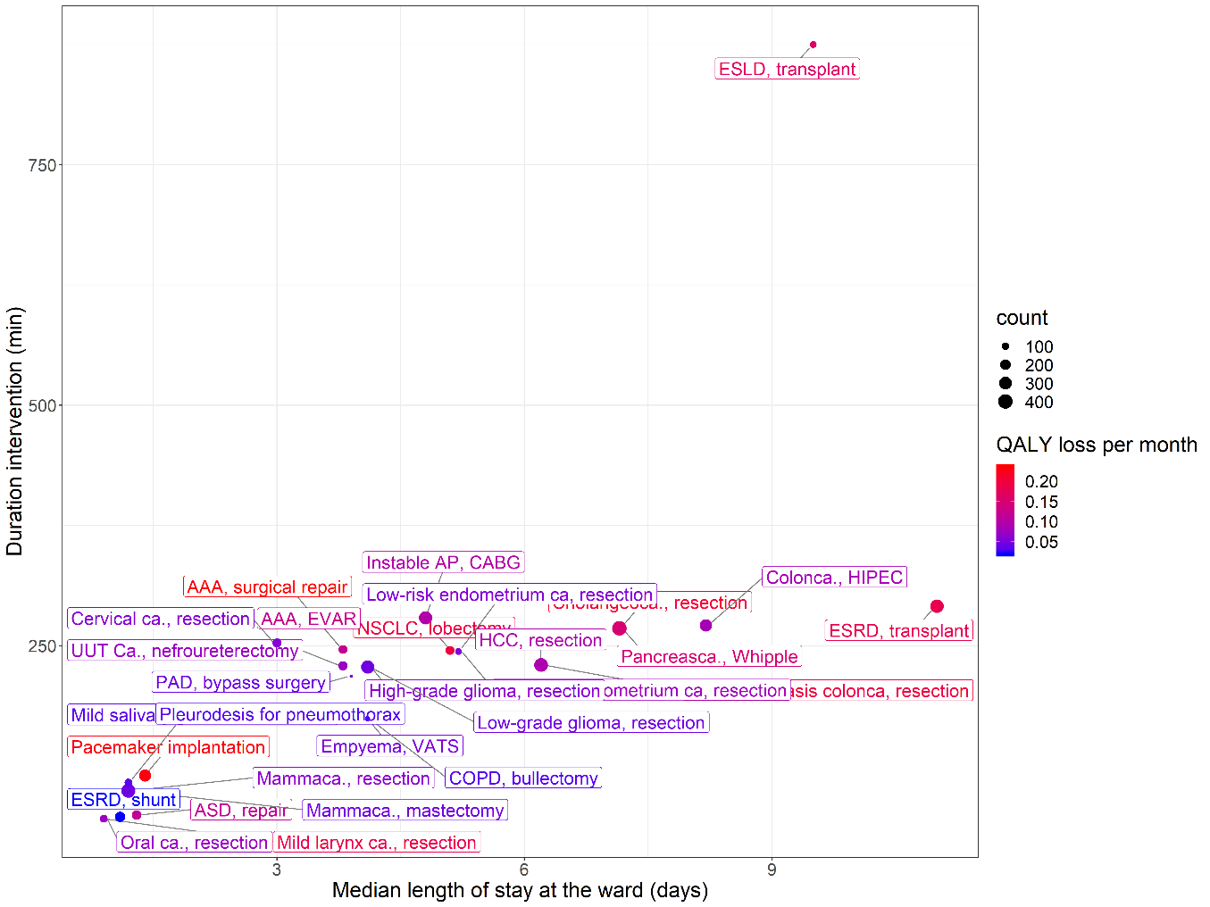

Figure 5, showing the mean duration of the intervention, the mean length of stay, and the frequency that interventions are performed in our hospital. The color coding represents their urgency in terms of QALY loss per week. The length of stay in days on the X-axis is the median length of stay within the hospital. This include both intensive care and non-intensive care stay. In Table 1, the length of stay is also showed separately for the ICU stay and non-ICU stay. ESRD: end-stage renal disease; ASD: atrial septum defect; VATS: video assisted thoracoscopic surgery; ESLD: end-stage liver disease; AAA: aneurysm of the abdominal aorta; AP: angina pectoris; CABG: coronary artery bypass graft; PCI: percutaneous coronary intervention; NSCLC: non-small cell lung carcinoma; EVAR: endovascular aortic repair; ca.: carcinoma; PAD: peripheral arterial disease; HCC: hepatocellular carcinoma; ESHF: end-stage heart failure; HIPEC: hyperthermic intraperitoneal chemotherapy.

## Disclosures

**ADD DISCLOSURES (Please add your personal disclosures!)**

Eline Krijkamp was supported by the Society for Medical Decision Making (SMDM) fellowship through a grant by the Gordon and Betty Moore Foundation (GBMF7853).

Acknowledgement **(Please add anyone we have to acknowledge here)**

We are grateful for H. Karreman and C. Van der Velden - van der Graaf for the work they have done for the quality of life data collection. Moreoever, we want to thank Ruben Goedhart for extracting the data from the electronic patient registry.

References

1. Office of the Assistant Secretary for Preparedness H. Pandemic Influenza Plan - Update IV (December 2017). 2017.

2. Emanuel EJ, Persad G, Upshur R, et al. Fair Allocation of Scarce Medical Resources in the Time of Covid-19. N Engl J Med 2020;1–7.

3. D’Agostino A, Demartini B, Cavallotti S, Gambini O. Mental health services in Italy during the COVID-19 outbreak. The Lancet Psychiatry. 2020;7(5):385–7.

4. Lazzerini M, Barbi E, Apicella A, Marchetti F, Cardinale F, Trobia G. Delayed access or provision of care in Italy resulting from fear of COVID-19. Lancet Child Adolesc. Heal. 2020;4(5):e10–1.

5. Harahsheh AS, Dahdah N, Newburger JW, et al. Missed or Delayed Diagnosis of Kawasaki Disease During the 2019 Novel Coronavirus Disease (COVID-19) Pandemic. J Pediatr Pandemic J Pediatr [Internet] 2020 [cited 2020 May 15];Available from: https://doi.org/10.1016/j.jpeds.2020.04.052.

6. NZA. Analyse van de gevolgen van de coronacrisis voor de reguliere zorg [Internet]. 2020 [cited 2020 May 17]. Available from: https://zorgdomein.com/media/documents/NZa-analyse_van_de_gevolgen_van_de_coronacrisis_voor_de_reguliere_zorg_-....pdf

7. Chang H-J, Huang N, Lee C-H, Hsu Y-J, Hsieh C-J, Chou Y-J. The Impact of the SARS Epidemic on the Utilization of Medical Services: SARS and the Fear of SARS. Am J Public Health [Internet] 2004;94(4):562–4. Available from: http://ajph.aphapublications.org/doi/10.2105/AJPH.94.4.562

8. Powell SN, Mullen T, Young L, Heald D, Iv ETP. SARS-CoV-2 Impact on Elective Orthopaedic Surgery: Implications for Post-Pandemic Recovery. J Bone Jt Surg 2020;

9. Vergano M, Bertolini G, Giannini A, et al. Clinical Ethics Recommendations for the Allocation of Intensive Care Treatments in exceptional, resource-limited circumstances [Internet]. 2020 [cited 2020 May 17]. Available from: http://www.siaarti.it/SiteAssets/News/COVID19 - documenti SIAARTI/SIAARTI - Covid-19 - Clinical Ethics Reccomendations.pdf

10. Daugherty Biddison L, Berkowitz KA, Courtney B, et al. Ethical considerations: Care of the critically ill and injured during pandemics and disasters: CHEST consensus statement. Chest 2014;146(4 Suppl):e145S-e155S.

11. Bayer R. Ethical Considerations for Decision Making Regarding Allocation of Mechanical Ventilators during a Severe Influenza Pandemic or Other Public Health Emergency. 2011.

12. York State Department of Health N. VENTILATOR ALLOCATION GUIDELINES New York State Task Force on Life and the Law New York State Department of Health. 2015.

13. Toner E, Waldhorn R. Responding to pandemic influenza - The ethical framework for policy and planning | Information | Health Service Journal [Internet]. 2020 [cited 2020 May 17];Available from: https://www.hsj.co.uk/swine-flu/responding-to-pandemic-influenza-the-ethical-framework-for-policy-and-planning/5005219.article

14. Garner RT, Rosen B. Moral Philosophy: A Systematic Introduction to Normative Ethics and Meta-Ethics. New York: Macmillan; 1967.

15. Qadan M, Hong TS, Tanabe KK, Ryan DP, Lillemoe KD. A Multidisciplinary Team Approach for Triage of Elective Cancer Surgery at the Massachusetts General Hospital During the Novel Coronavirus COVID-19 Outbreak. Ann Surg 2020;1.

16. MacCormick AD, Parry BR. Judgment analysis of surgeons’ prioritization of patients for elective general surgery. Med Decis Making [Internet] 2006 [cited 2020 Mar 27];26(3):255–64. Available from: http://www.ncbi.nlm.nih.gov/pubmed/16751324

17. Husereau D, Drummond M, Petrou S, et al. Consolidated Health Economic Evaluation Reporting Standards (CHEERS) statement. Eur J Heal Econ 2013;

18. Alarid-Escudero F, Krijkamp EM, Enns EA, Hunink MGM, Pechlivanoglou P, Jalal H. Cohort state-transition models in R: From conceptualization to implementation. 2020 [cited 2020 May 19];Available from: http://arxiv.org/abs/2001.07824

19. Alarid-Escudero F, Krijkamp EM, Pechlivanoglou P, et al. A Need for Change! A Coding Framework for Improving Transparency in Decision Modeling. Pharmacoeconomics 2019;37(11):1329–39.

20. Zorginstituut Nederland. Richtlijn voor het uitvoeren van economische evaluaties in de gezondheidszorg. 2016;

21. Siebert U, Alagoz O, Bayoumi AM, et al. State-Transition Modeling: A Report of the ISPOR-SMDM Modeling Good Research Practices Task Force-3. Value Heal [Internet] 2012;15(6):812–20. Available from: http://eprints.gla.ac.uk/73437/

22. Sonnenberg FA, Beck JR. Markov Models in Medical Decision Making. Med Decis Mak [Internet] 1993 [cited 2018 Nov 15];13(4):322–38. Available from: http://journals.sagepub.com/doi/10.1177/0272989X9301300409

23. Hunink M, Mc E, Glasziou P, Elstein A. Decision Making in Health and Medicine: Integrating Evidence and Values [Internet]. 2nd ed. Cambridge: Cambridge University Press; 2003 [cited 2020 May 19]. Available from: http://www.cambridge.org

24. Klarman H, Rosenthal GD. Cost Effectiveness Analysis Applied to the Treatment of Chronic Renal Disease. Med Care [Internet] 1968 [cited 2020 May 11];6.1:48–54. Available from: https://www.jstor.org/stable/3762651?casa_token=PBjn8CVNsEUAAAAA:Qz-0ARl86RMuto-iy4CfBlNhpHIEvFPKiQ5MyuBfuZOih82MBB5dYOsKO-P4wZX9_J1Qh92HEUHDel6W2TO172lSHMIoHJx4KeMoP03NLSvVyss5wKaP&seq=7#metadata_info_tab_contents

25. Kankersoorten - IKNL [Internet]. [cited 2020 May 19];Available from: https://iknl.nl/kankersoorten

26. NHR [Internet]. [cited 2020 May 19];Available from: https://nederlandsehartregistratie.nl/

27. CBS. Sterftekansen naar leeftijd, geslacht, opleidingsniveau [Internet]. [cited 2020 May 19];Available from: https://www.cbs.nl/nl-nl/maatwerk/2017/23/sterftekansen-naar-leeftijd-geslacht-opleidingsniveau

28. Global Burden of Disease Collaborative Network. Global Burden of Disease Study 2016 (GBD 2016) Disability Weights. Seattle, United States: Institute for Health Metrics and Evaluation (IHME): 2017.

29. General Guidance for DALYs calculation [Internet]. [cited 2020 May 19]. Available from: https://montagu.vaccineimpact.org/contribution/resources/c978e5a1acf6a502679c92200e78ef61.pdf

30. Disability-adjusted life years (DALYs) [Internet]. [cited 2020 May 19];Available from: https://www.who.int/data/gho/indicator-metadata-registry/imr-details/158

31. Stouthard EA, Essink-Bot M-L, Bonsel GJ. Disability weights for diseases A modified protocol and results for a Western European region. Eur J Public Health [Internet] 2000 [cited 2020 May 14];10(1):24–30. Available from: https://academic.oup.com/eurpub/article-abstract/10/1/24/490779

32. Salomon JA, Haagsma JA, Davis A, et al. Disability weights for the Global Burden of Disease 2013 study [Internet]. 2015 [cited 2020 May 14]. Available from: www.thelancet.com/lancetgh

33. Chen EY, Mayo SC, Sutton T, et al. Effect of Time to Surgery of Colorectal Liver Metastases on Survival. J Gastrointest Cancer 2020;

34. Yusuf S, Zucker D, Passamani E, et al. Effect of coronary artery bypass graft surgery on survival: overview of 10-year results from randomised trials by the Coronary Artery Bypass Graft Surgery Trialists Collaboration. Lancet 1994;344(8922):563–70.

35. Noorbakhsh A, Tang JA, Marcus LP, et al. Gross-total resection outcomes in an elderly population with glioblastoma: A SEER-based analysis. Clinical article. J Neurosurg 2014;120(1):31–9.

36. Nakano R, Ohira M, Kobayashi T, et al. Hepatectomy versus stereotactic body radiotherapy for primary early hepatocellular carcinoma: A propensity-matched analysis in a single institution. Surg (United States) 2018;164(2):219–26.

37. Lee JN, Kwon SY, Choi GS, et al. Impact of surgical wait time on oncologic outcomes in upper urinary tract urothelial carcinoma. J Surg Oncol 2014;110(4):468–75.

38. Lim C, Bhangui P, Salloum C, et al. Impact of time to surgery in the outcome of patients with liver resection for BCLC 0-A stage hepatocellular carcinoma. J Hepatol 2018;68(1):100–8.

39. Moss AJ, Jackson Hall W, Cannom DS, et al. Improved survival with an implanted defibrillator in patients with coronary disease at high risk for ventricular arrhythmia. N Engl J Med 1996;335(26):1933–40.

40. Scott SWM, Batchelder AJ, Kirkbride D, Naylor AR, Thompson JP. Late Survival in Nonoperated Patients with Infrarenal Abdominal Aortic Aneurysm. Eur J Vasc Endovasc Surg 2016;52(4):444–9.

41. Nyboe C, Karunanithi Z, Nielsen-Kudsk JE, Hjortdal VE. Long-term mortality in patients with atrial septal defect: a nationwide cohort-study. [cited 2020 May 19];Available from: https://academic.oup.com/eurheartj/article-abstract/39/12/993/4675086

42. Wang J, Yan C, Fu A. A randomized clinical trial of comprehensive education and care program compared to basic care for reducing anxiety and depression and improving quality of life and survival in patients with hepatocellular carcinoma who underwent surgery. Medicine (Baltimore) 2019;98(44):e17552.

43. Brewster DC, Jones JE, Chung TK, et al. Long-term outcomes after endovascular abdominal aortic aneurysm repair: The First Decade. Ann. Surg. 2006;244(3):426–36.

44. Brunner M, Olschewski M, Geibeli A, Bode C, Zehender M. Long-term survival after pacemaker implantation: Prognostic importance of gender and baseline patient characteristics. Eur Heart J 2004;25(1):88–95.

45. Rose EA, Gelijns AC, Moskowitz AJ, et al. Long-term use of a left ventricular assist device for end-stage heart failure. N Engl J Med 2001;345(20):1435–43.

46. Mazzone E, Preisser F, Nazzani S, et al. More Extensive Lymph Node Dissection Improves Survival Benefit of Radical Cystectomy in Metastatic Urothelial Carcinoma of the Bladder. Clin Genitourin Cancer 2019;17(2):105-113.e2.

47. Kann BH, Verma V, Stahl JM, et al. Multi-institutional analysis of stereotactic body radiation therapy for operable early-stage non-small cell lung carcinoma. Radiother Oncol 2019;134:44–9.

48. Huang CE, Yang YH, Chen WC, et al. Nephroureterectomy increase 5 year survival in patients on dialysis with upper urinary tract urothelial carcinoma. Oncotarget 2017;8(45):79876–83.

49. Shalowitz DI, Epstein AJ, Ko EM, Giuntoli RL. Non-surgical management of ovarian cancer: Prevalence and implications. Gynecol Oncol 2016;142(1):30–7.

50. Pedregal-Mallo D, Sánchez Canteli M, López F, Álvarez-Marcos C, Llorente JL, Rodrigo JP. Oncological and functional outcomes of transoral laser surgery for laryngeal carcinoma. Eur Arch Oto-Rhino-Laryngology 2018;275(8):2071–7.

51. Kim WR, Lake JR, Smith JM, et al. OPTN/SRTR 2016 Annual Data Report: Liver. Am J Transplant 2018;18:172–253.

52. Muluk SC, Muluk VS, Kelley ME, et al. Outcome events in patients with claudication: A 15-year study in 2777 patients. J Vasc Surg 2001;33(2):251–8.

53. Verwaal VJ, Bruin S, Boot H, Van Slooten G, Van Tinteren H. 8-Year follow-up of randomized trial: Cytoreduction and hyperthermic intraperitoneal chemotherapy versus systemic chemotherapy in patients with peritoneal carcinomatosis of colorectal cancer. Ann Surg Oncol 2008;15(9):2426–32.

54. Holtzman A, Morris CG, Amdur RJ, Dziegielewski PT, Boyce B, Mendenhall WM. Outcomes after primary or adjuvant radiotherapy for salivary gland carcinoma. Acta Oncol (Madr) 2017;56(3):484–9.

55. Murphy MM, Simons JP, Hill JS, et al. Pancreatic resection: A key component to reducing racial disparities in pancreatic adenocarcinoma. Cancer 2009;115(17):3979–90.

56. Mikkola R, Kelahaara J, Heikkinen J, Lahtinen J, Biancari F. Poor late survival after surgical treatment of pleural empyema. World J Surg 2010;34(2):266–71.

57. Keeley EC, Boura JA, Grines CL. Primary angioplasty versus intravenous thrombolytic therapy for acute myocardial infarction: a quantitative review of 23 randomised trials. Lancet [Internet] 2003 [cited 2020 May 19];361(9351):13–20. Available from: https://linkinghub.elsevier.com/retrieve/pii/S0140673603121137

58. Piehler JM, Crichlow RW. Primary Carcinoma of the Gallbladder. Arch Surg 1977;112(1):26–30.

59. Warner L, Chudasama J, Kelly CG, et al. Radiotherapy versus open surgery versus endolaryngeal surgery (with or without laser) for early laryngeal squamous cell cancer. Cochrane Database Syst. Rev. 2014;2014(12).

60. Warlow C, Farrell B, Fraser A, Sandercock P, Slattery J. Randomised trial of endarterectomy for recently symptomatic carotid stenosis: Final results of the MRC European Carotid Surgery Trial (ECST). Lancet 1998;351(9113):1379–87.

61. Soran A, Ozmen V, Ozbas S, et al. Randomized Trial Comparing Resection of Primary Tumor with No Surgery in Stage IV Breast Cancer at Presentation: Protocol MF07-01. Ann Surg Oncol 2018;25(11):3141–9.

62. Ginsberg RJ, Rubinstein L V. Randomized trial of lobectomy versus limited resection for T1 N0 non-small cell lung cancer. Ann Thorac Surg 1995;60(3):615–23.

63. Redden MD, Chin TY, van Driel ML. Surgical versus non-surgical management for pleural empyema. Cochrane Database Syst. Rev. 2017;2017(3).

64. Konstantinides S, Geibel A, Olschewski M, et al. A comparison of surgical and medical therapy for atrial septal defect in adults. N Engl J Med 1995;333(8):469–73.

65. Sørensen VR, Heaf J, Wehberg S, Sørensen SS. Survival Benefit in Renal Transplantation Despite High Comorbidity. Transplantation 2016;100(10):2160–7.

66. Shalowitz DI, Epstein AJ, Buckingham L, Ko EM, Giuntoli RL. Survival implications of time to surgical treatment of endometrial cancers. Am J Obstet Gynecol 2017;216(3):268.e1-268.e18.

67. van Harten M, de Ridder M, Hamming-Vrieze O, Smeele L, Balm A, van den Brekel M. The association of treatment delay and prognosis in head and neck squamous cell carcinoma (HNSCC) patients in a Dutch comprehensive cancer center. Oral Oncol [Internet] 2014 [cited 2020 May 19];50(4):282–90. Available from: https://www.ncbi.nlm.nih.gov/pubmed/24405882

68. Stewart JM, Tone AA, Jiang H, et al. The optimal time for surgery in women with serous ovarian cancer. Can J Surg 2016;59(4):223–32.

69. Davies L, Welch G. Thyroid cancer survival in the United States: Observational data from 1973 to 2005. Arch Otolaryngol - Head Neck Surg 2010;136(5):440–4.

70. Bleicher RJ, Ruth K, Sigurdson ER, et al. Time to surgery and breast cancer survival in the United States. JAMA Oncol 2016;2(3):330–9.

71. Morse E, Fujiwara RJT, Judson B, Mehra S. Treatment Times in Salivary Gland Cancer: National Patterns and Association with Survival. Otolaryngol - Head Neck Surg (United States) 2018;159(2):283–92.

72. USRDS [Internet]. [cited 2020 May 19];Available from: https://www.usrds.org/2015/view/

73. Kirkegård J, Mortensen FV, Hansen CP, Mortensen MB, Sall M, Fristrup C. Waiting time to surgery and pancreatic cancer survival: A nationwide population-based cohort study. Eur J Surg Oncol 2019;45(10):1901–5.

74. Chung JH, Lee SH, Kim KT, Jung JS, Son HS, Sun K. Optimal Timing of Thoracoscopic Drainage and Decortication for Empyema. Ann Thorac Surg 2014;97(1):224–9.

75. Fein DA, Mendenhall WM, Parsons JT, et al. Carcinoma of the oral tongue: A comparison of results and complications of treatment with radiotherapy and/or surgery. Head Neck 1994;16(4):358–65.

76. Organ Procurement and Transplantation Network [Internet]. [cited 2020 May 19];Available from: https://optn.transplant.hrsa.gov/data/view-data-reports/national-data/

77. Jakola AS, Myrmel KS, Kloster R, et al. Comparison of a strategy favoring early surgical resection vs a strategy favoring watchful waiting in low-grade gliomas. JAMA - J Am Med Assoc 2012;308(18):1881–8.

78. Haruna A, Muro S, Nakano Y, et al. CT scan findings of emphysema predict mortality in COPD. Chest 2010;138(3):635–40.

79. Ruys AT, Heuts SG, Rauws EA, Busch ORC, Gouma DJ, Van Gulik TM. Delay in surgical treatment of patients with hilar cholangiocarcinoma: Does time impact outcomes? HPB 2014;16(5):469–74.

80. Shin DW, Cho J, Kim SY, et al. Delay to curative surgery greater than 12 weeks is associated with increased mortality in patients with colorectal and breast cancer but not lung or thyroid cancer. Ann Surg Oncol 2013;20(8):2468–76.

81. Jonsen AR. 3. Bentham in a Box: Technology Assessment and Health Care Allocation. Law, Med Heal Care [Internet] 1986 [cited 2020 May 19];14(3–4):172–4. Available from: http://journals.sagepub.com/doi/10.1111/j.1748-720X.1986.tb00974.x

82. Ae LXC, Reichman ME, Ae BAM, et al. Impact of socioeconomic status on cancer incidence and stage at diagnosis: selected findings from the surveillance, epidemiology, and end results: National Longitudinal Mortality Study. Cancer Causes Control 2009;20:417–35.

83. Pettitt D, Raza S, Naughton B, et al. The Limitations of QALY: A Literature Review. J Stem Cell Res Ther 2016;6(4).

## Appendix A

An overview per disease of the distribution and source of the input parameters and a graphical representation of the output of the model.

## Appendix B

A summary of the estimates of the decision model and an overview of the counts, duration, and length of stay of the included interventions in our hospital.

## Appendix C

Formulas to convert survival data into risk per week.

## Appendix D

Calibrated visual analogue scale based on the Global burden of disease study. *Do we like to add a description of our expert panel? And the results we have of the WHO data. And have a full description of the method?*